KENDRIYA VIDYALAYA No 3 , JHANSI
COCURRICULAR ACTIVITIES
INNOVATIVE EXPERIMENTS/PROJECTS TAKEN IN THE CURRICULAR /
CO-CURRICULAR AREAS
SPIC MACAY
PRGORAMME CONDUCTED FOR SPREADING AWARENESS REGARDING INDIAN CULTURE ,MUSIC & INCULCATING HUMAN VALUES
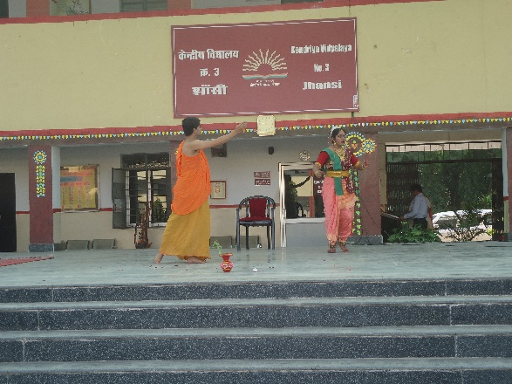 | 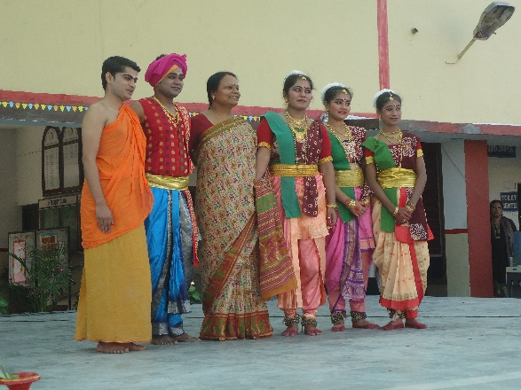
PRGORAMME CONDUCTED FOR SPREADING AWARENESS REGARDING INDIAN CULTURE ,MUSIC & INCULCATING HUMAN VALUES
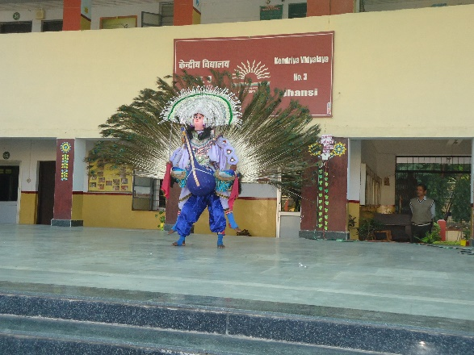 | 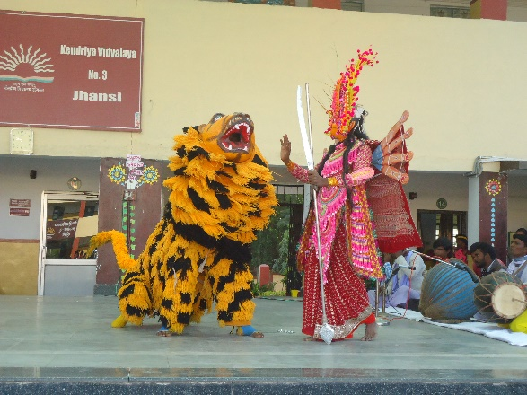
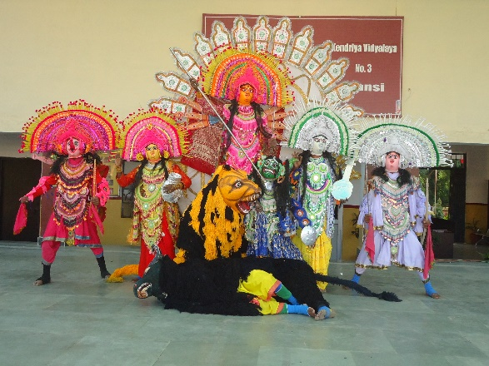 | 